1. 
2. 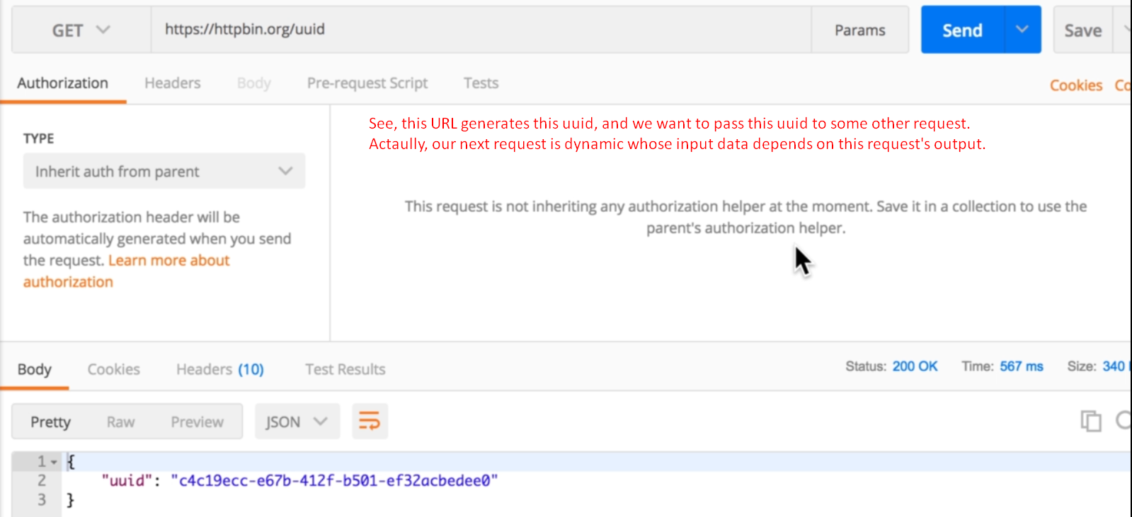
3. 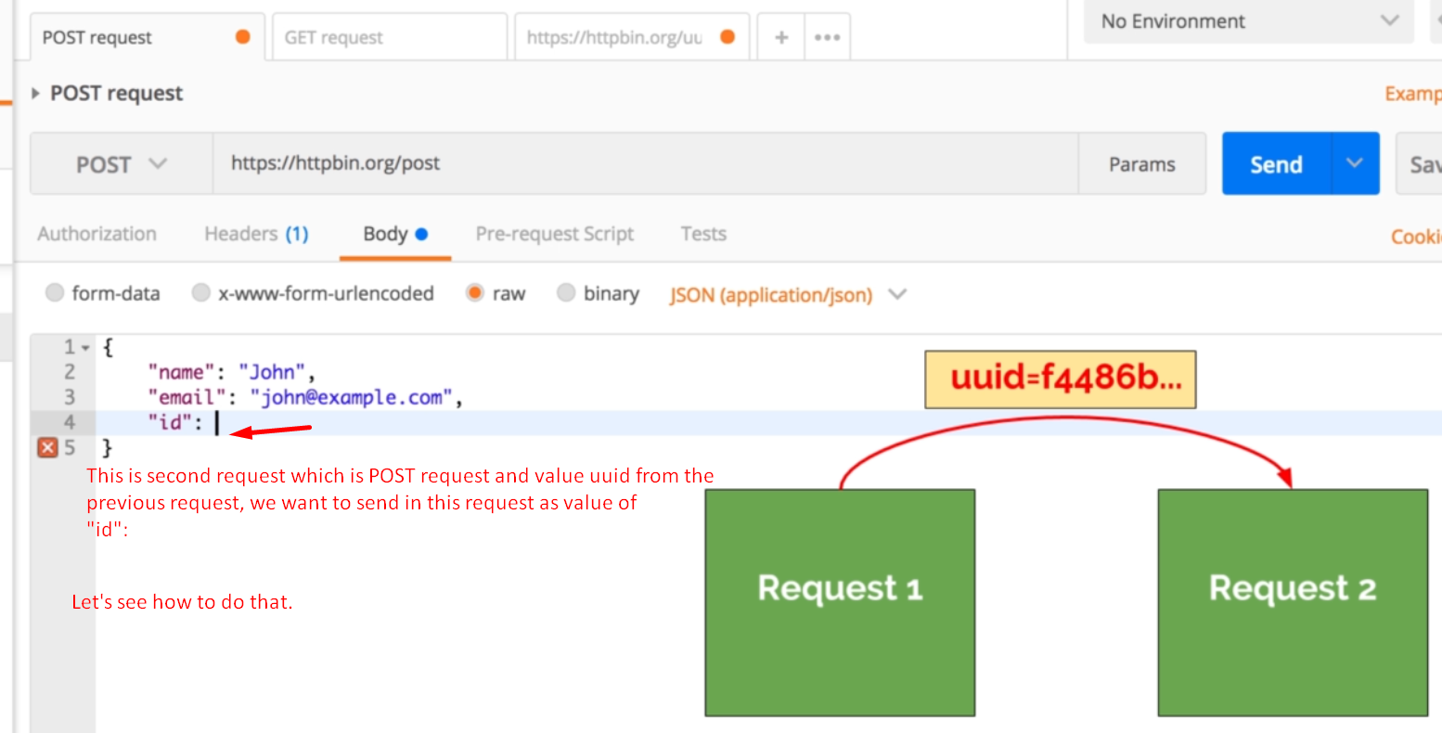
4. We can use the important feature of Postman that is “**variable**”.   
   And in order to work with variables, we need to dive a bit in a code.
5. Just click on the tab “test” which allows us
   1. To write tests by writing a piece of code.
6.   
   After receiving the response, the code in this “Tests” tab is executed.
7. 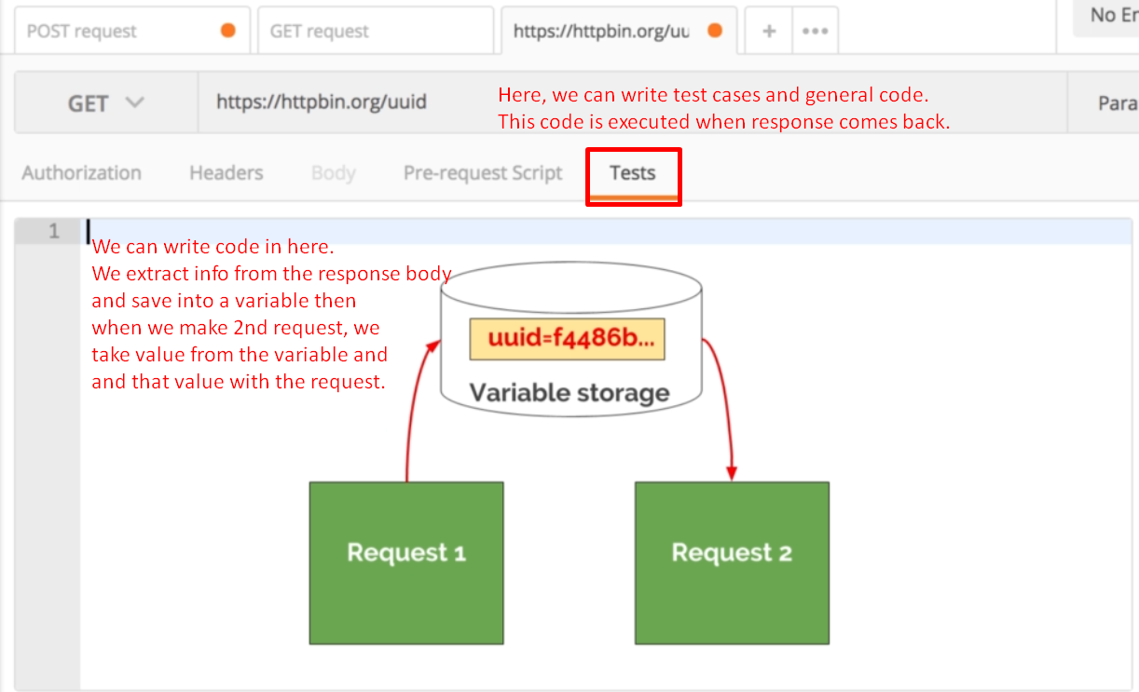
8. 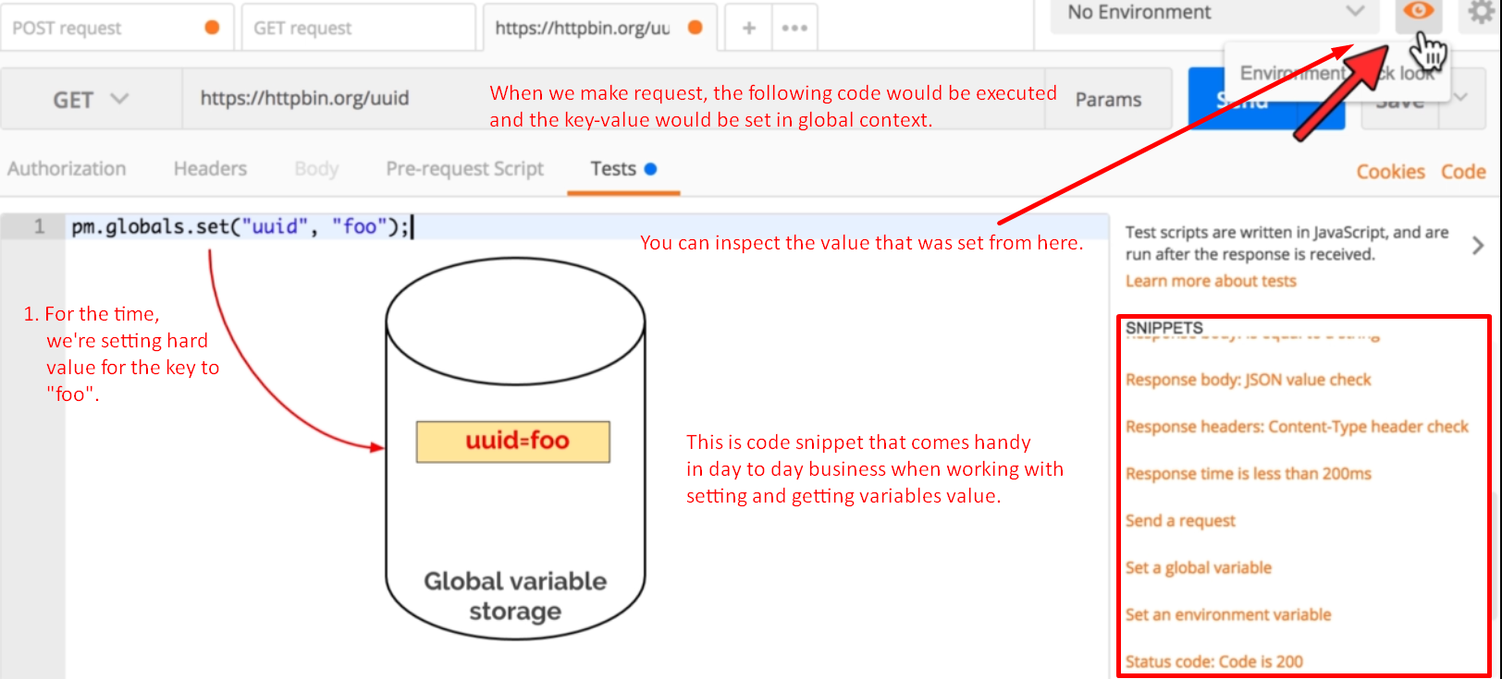  
   We will talk about what is global, environment variables etc.
9. 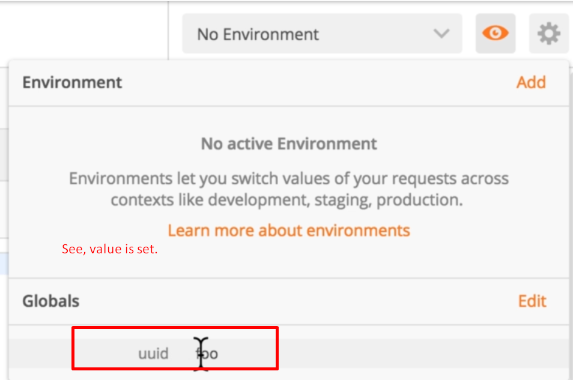
10. 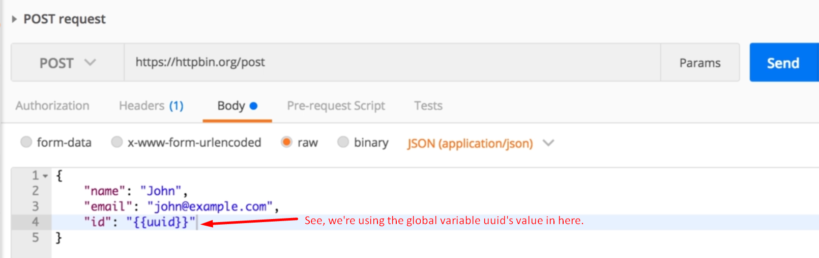
11. 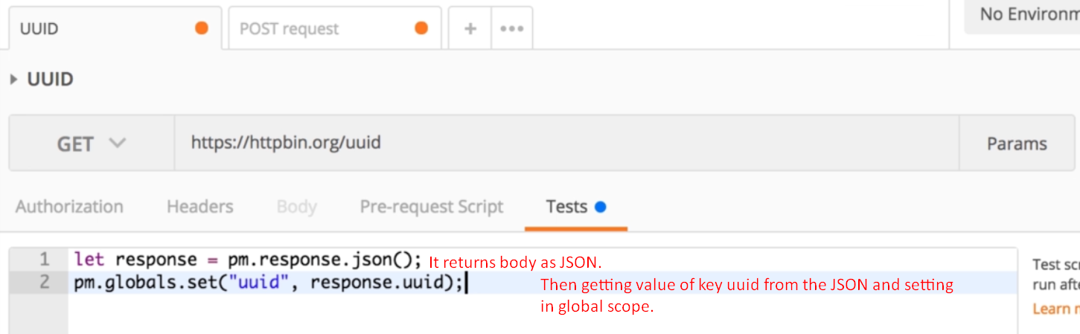
12. 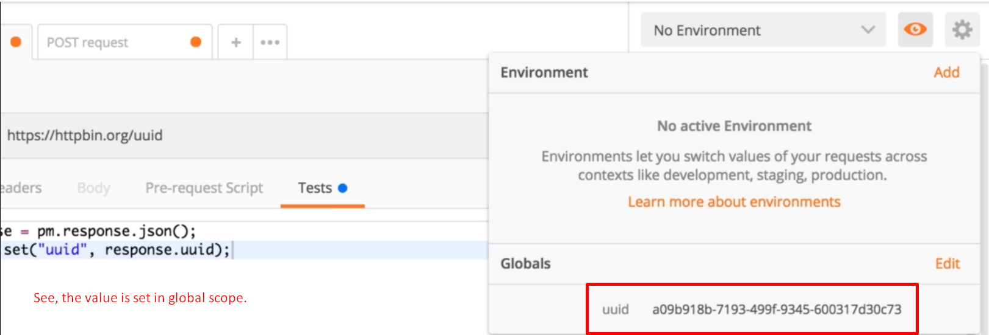
13. 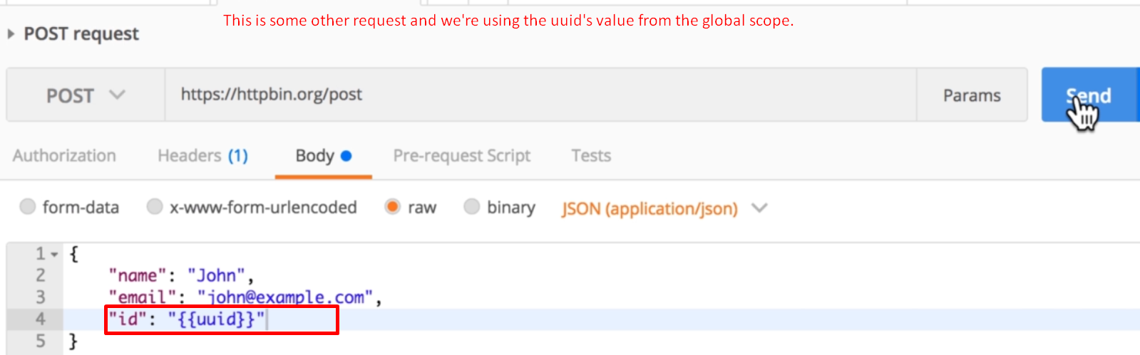
14. 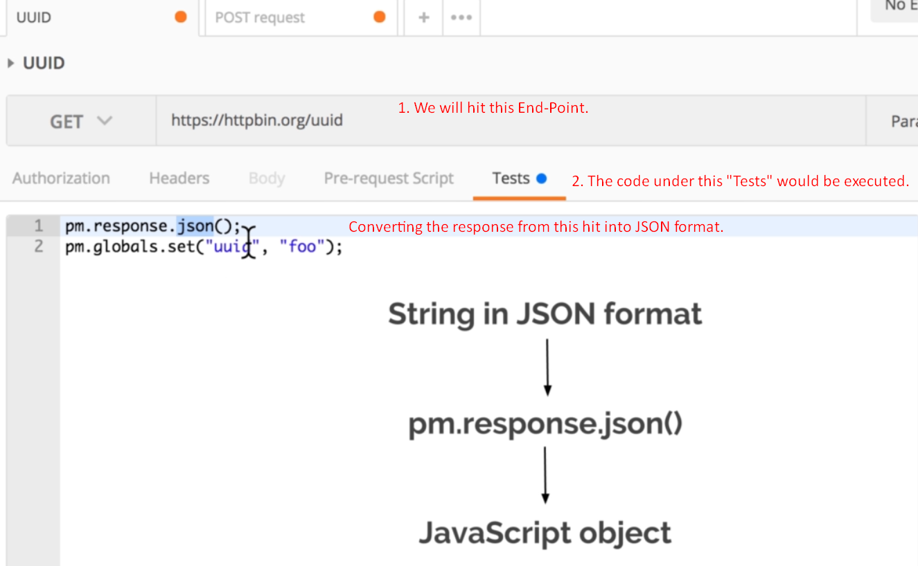

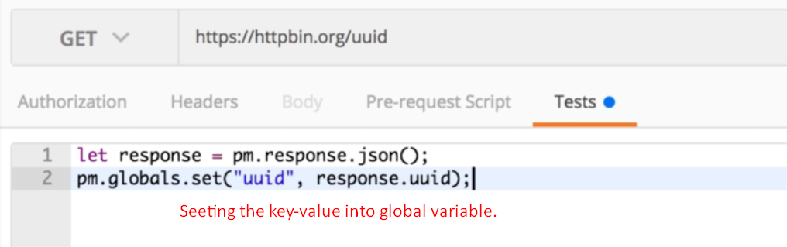  
 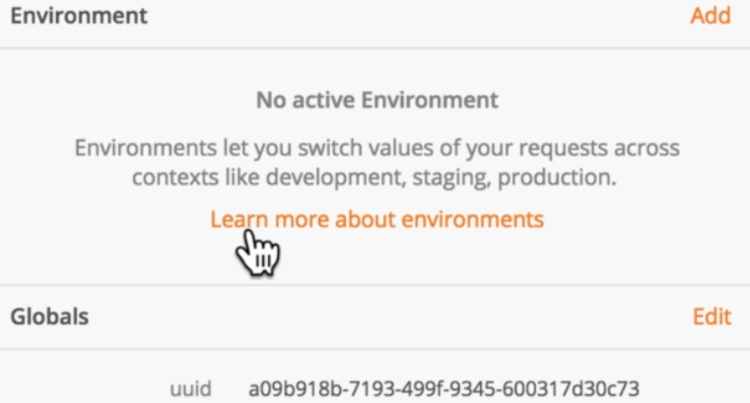

1.   
   Select one option from the **SNIPPETS** on the right hand side.
2. 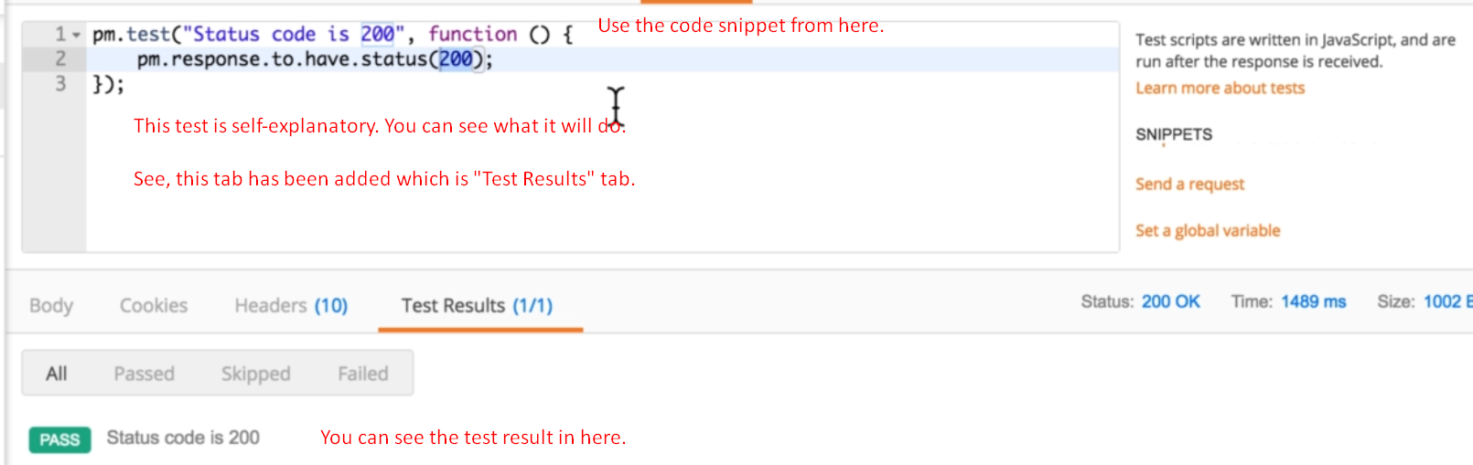  
     
   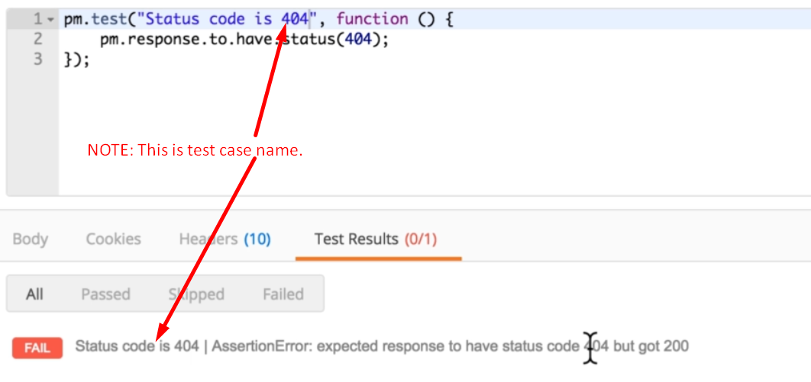
3. 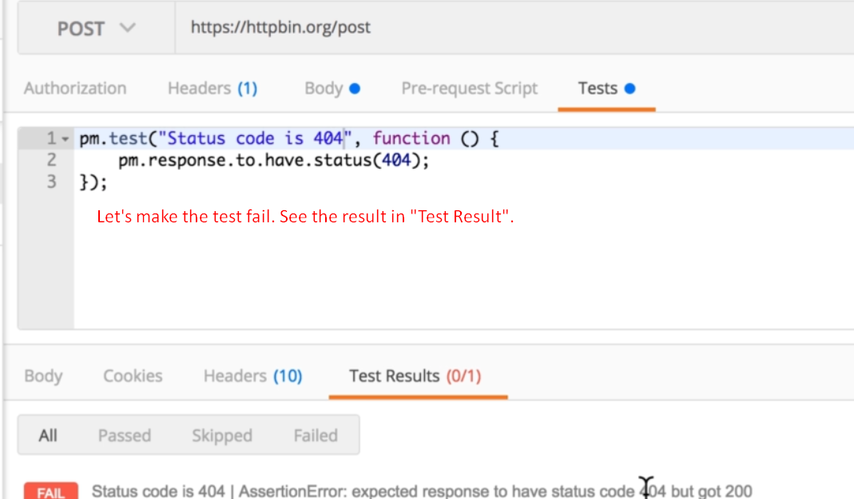
4. Let’s see how to run requests in sequence one after the other.
5. For that we use Postman runner.
6. 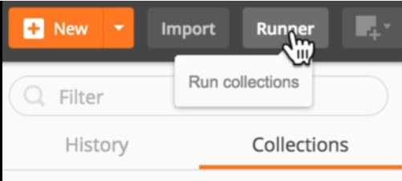
7. 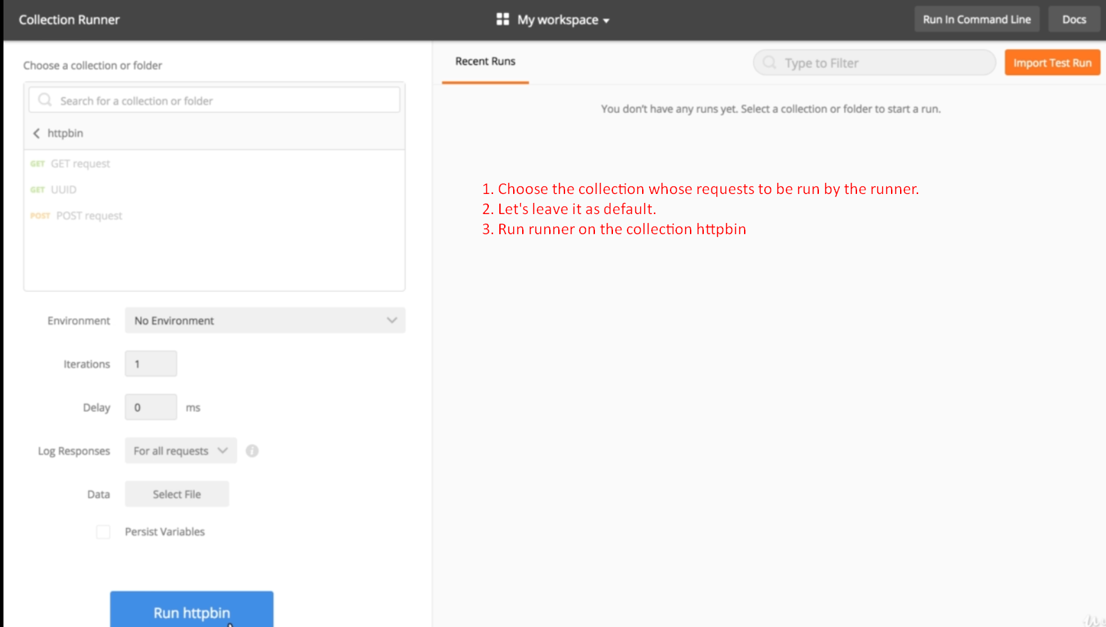
8. 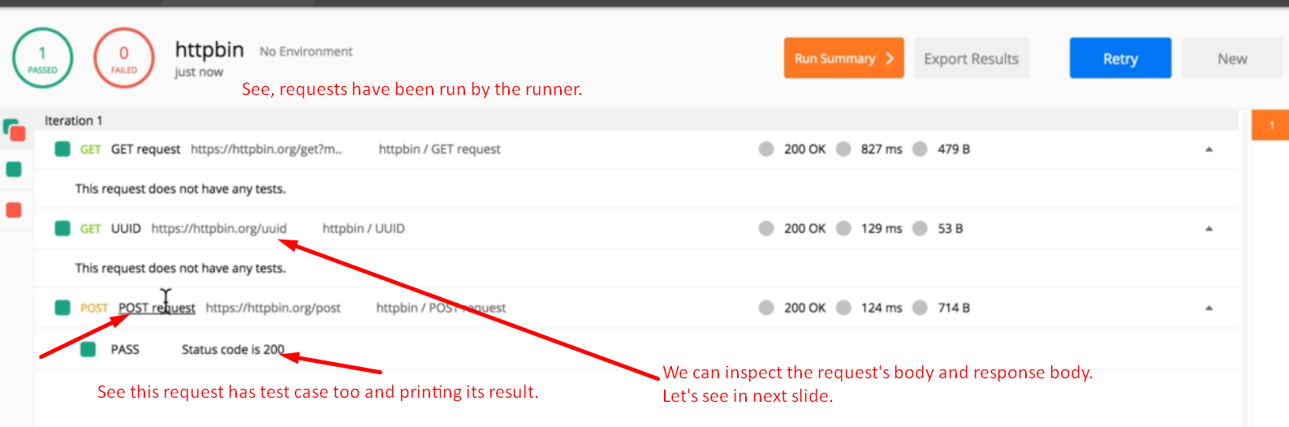
9. 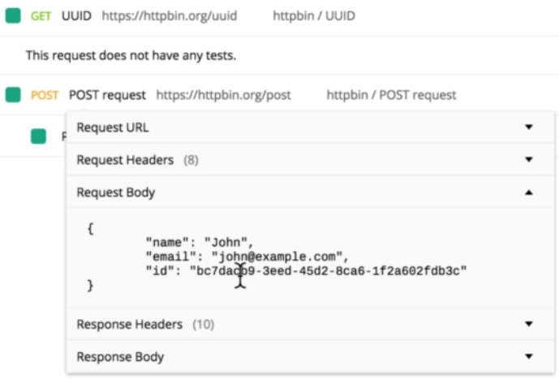
10. 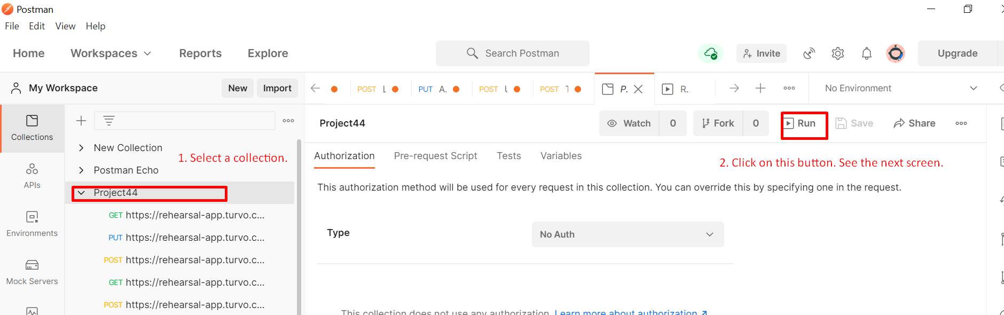
11. 